

Foundations of Programming

Assignment No.: 22
PROBLEM STATEMENT: Write a menu driven program in C to perform various string operations using in-built functions.

OBJECTIVE:

- To understand the concept of strings in the C programming language.
- To learn how to use built-in string functions for string manipulation.
- To perform operations such as length calculation, copying, concatenation, comparison, and reversal using menu options.
.

THEORY:
In the C programming language, a string is a sequence of characters terminated by a null character ('\0'). Strings are stored in character arrays and manipulated using functions available in the string.h header file.
Common built-in string functions include strlen() for finding the length of a string, strcpy() for copying one string to another, strcat() for concatenating two strings, and strcmp() for comparing two strings.
A menu driven program allows the user to select different operations from a list of options. Based on the user’s choice, the corresponding string function is executed. This approach makes the program interactive and easy to use.

PLATFORM: Linux
ALGORITHM:
- Start
- Declare two string variables str1 and str2, integer variables choice, len, and result.
- Input the first string str1.
- Input the second string str2.
- Display the menu with the following options:

    - Find Length of String

    - Copy String

    - Concatenate Strings

    - Compare Strings

    - Reverse String

    - Exit
- Enter the user's choice.
- Use a switch statement to perform the selected operation:
  - Case 1:
Find the length of str1 using strlen() and display the result.
  - Case 2:
Copy str1 into str2 using strcpy() and display the copied string.
  - Case 3:
Concatenate str1 and str2 using strcat() and display the result.
  - Case 4:
Compare str1 and str2 using strcmp().
    - If result is 0, display "Strings are equal".
    - Otherwise, display "Strings are not equal".
  - Case 5:
Reverse str1 using strrev() and display the reversed string.
  - Case 6:
Exit the program.
  - Default:
Display "Invalid choice".
- Repeat steps 5 to 7 until the user selects Exit.
- Stop.
FLOWCHART:
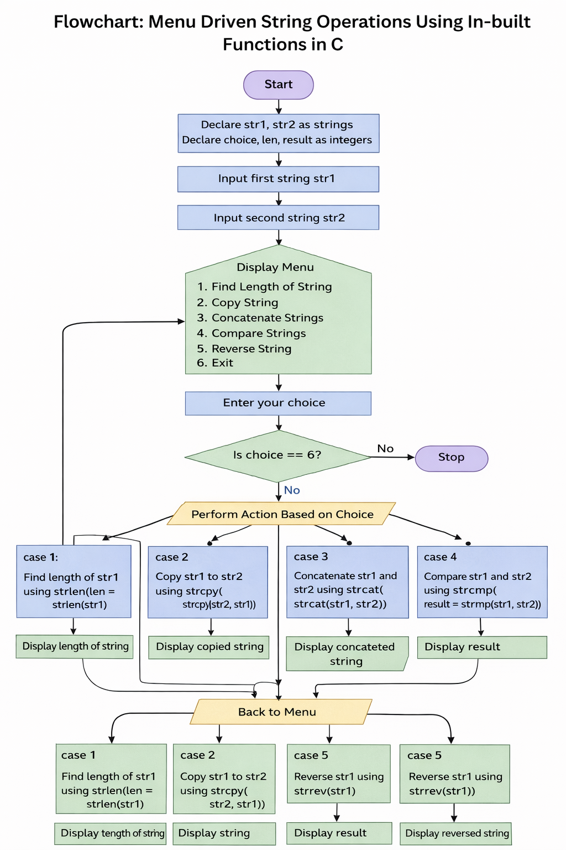
PROGRAM:
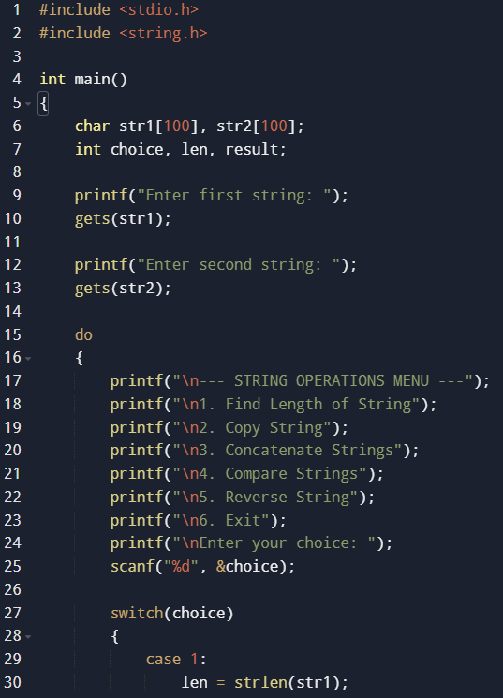

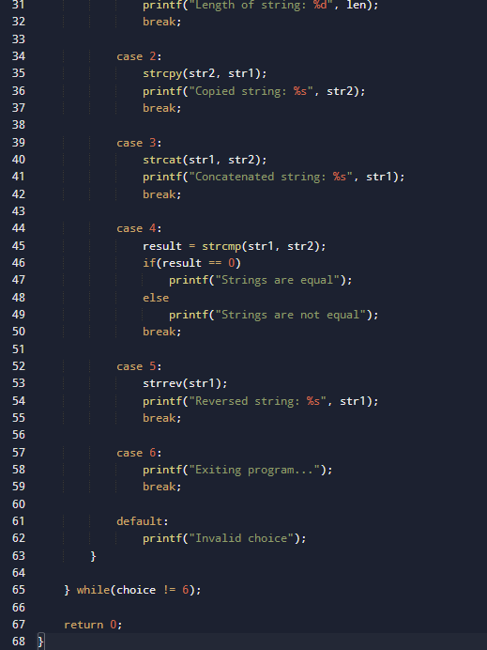
INPUT: Two strings entered by the user.

OUTPUT: Displays results of different string operations such as length, copy, concatenation, and comparison.

SAMPLE INPUT:
Enter first string: Hello
Enter second string: World
Choice: 3

SAMPLE OUTPUT:
Concatenated string: HelloWorld
CONCLUSION: Thus, the C program successfully demonstrates different string operations using built-in functions through a menu driven approach, making the program interactive and easy to use.

FAQs:
- What are built-in string functions in C and why are they used?
- What is the purpose of the string.h header file in C programs?
- How does a menu driven program improve user interaction in programming?

